**Shabbos Stories for**

**Parshas eikev 5780**

Volume 11, Issue 48 18 Menachem Av/August 8, 2020

**Printed L’illuy nishmas Nechama bas R’ Noach, a”h**

For a free subscription, please forward your request to [***keren18@juno.com***](mailto:keren18@juno.com)

Past stories can be found on the website **ShabbosStories.com**

**Just Four Days Left to Live**

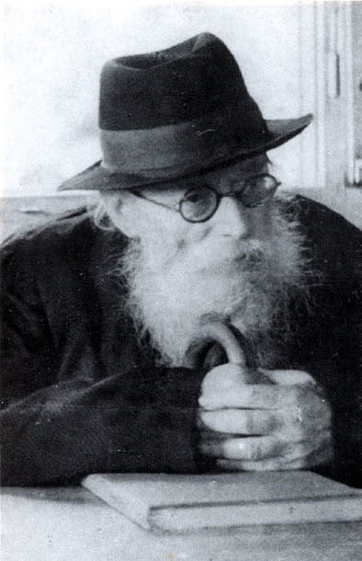

**The Chazon Ish, zt”l**

One day, a man who was very distraught came to the Chazon Ish (Rabbi Avrohom Yeshaya Karelitz, zt”l) for help and advice. He told the Chazon Ish that he was quite ill and that the doctors did not have any effective medication for him, and they had told the man that he had only four days left to live.

The Chazon Ish opened a Chumash to Parashas Bereishis, and turned to the first Pesukim of the Parshah. He said to the man, "Look what Hashem created on the first day," and the Chazon Ish began to recite all the things which Hashem created on the first day of Creation.

"Look what Hashem created on the second day," and again the Chazon Ish read the Pesukim, and listed one by one the things which were created on the second day. He continued with the third day, and the fourth day.

"If the Creator of the World was able to create so many things in four days, don't you believe that in four days He can create a medicine for you which will heal you completely? Four days is a very long time!"

The Chazon Ish encouraged the man not to give up hope, but rather, he should daven for himself and plead with Hashem that He heal him. He reminded the man that the Gates of Tefilah are never locked, especially before the Tefilah of a sick person— which is Tefilah at a time of Tzarah, distress.

The eyes of the man lit up at the words of the Chazon Ish and he began to daven fervently for himself, following the instructions of the Tzadik. An unbelievable miracle occurred, and a new medicine was imported to Eretz Yisroel from America in the following days. This sick man was one of the first people that the medicine was tested on, and it proved to be successful to fight his illness. Within a short time, the man was healed completely! (Borchi Nafshi)

*Reprinted from the Parshas Naso 5780 email of Torah U’Tefilah as compiled by Rabbi Yehuda Winzelberg.*

**The Amazing Power of the Shaagas Aryeh’s Tefillin**

How can one accept upon himself the yoke of Torah and Mitzvos? It can be explained with a story that happened to HaGaon HaRav Aryeh Leib Gunzberg, author of the Shaagas Aryeh, zt”l.

Once, while he was an attendant to the Great Rav, R’ Chaim of Volozhin, he had to travel by train, and he was wrapped in his Tallis and Tefilin, immersed deeply in prayer and learning. As he was travelling, his thoughts were never interrupted from the Torah, and he could not be distracted.

Also travelling in the same car was a plain, ordinary Jew who was also wearing his Tefilin, and his lips were murmuring in prayer. As the train was slowly rounding a bend in a deep forest, five armed robbers jumped aboard the train and announced a holdup.

“Give us all your money!” they shouted to all the passengers. The Shaagas Aryeh, who was deeply involved in learning, did not see or hear anything that was going on around him. When he finally heard the shouting and commotion, the Gaon looked up at the robbers, and with awe and fear from his gaze, they immediately and quickly ran away.

The other Jewish traveler turned to the Gaon and asked, “Rebbe, please teach me, why were the thieves more afraid of you, who appears old and weak, than from me who is young and strong?”

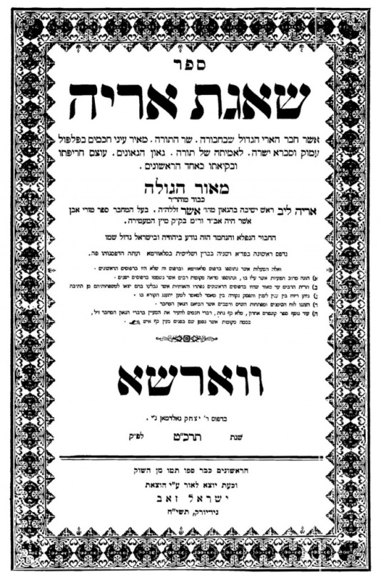

**Title Page of the Sefer Shaagas Aryeh**

The Shaagas Aryeh answered, “They did not run away from me, but rather, from the light of the holy Tefilin that are on me. ‘How do we know that Tefilin are the strength of Israel? For it is written (Devorim 28:10): 'All the nations of the world will see that the Name of Hashem is called upon you and they will be in awe of you'. And it was taught in a Braisa: Rebbe Eliezer HaGadol says: These are the Tefilin that are worn on the head.”

The Shaagas Aryeh explained, “It was the Tefilin that caused them to be afraid, and that is why they turned and fled.”

The young traveler responded: “What about my Tefilin? Why didn’t they see the light that was upon me?”

The Shaagas Aryeh explained to the traveler: “Examine the words of Rebbe Eliezer HaGadol very carefully. He did not say הראש שעל התפילין אלו ,these are the Tefilin that are on the head, but rather, אלו שבראש התפילין ,these are the Tefilin, that are in the head. The sanctity of the Tefilin must be permanently implanted within the head, and within the mind!”

*Reprinted from the Parshas Naso 5780 email of Torah U’Tefilah as compiled by Rabbi Yehuda Winzelberg.*

**The Tight Hand Grasp**

**Of the Chofetz Chaim**

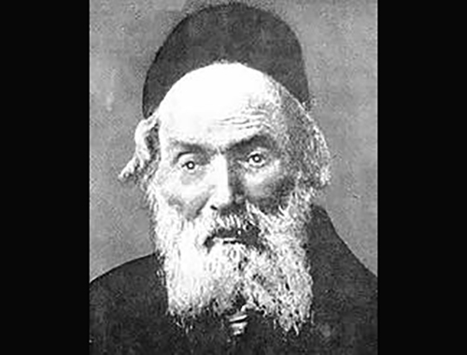

**The Chofetz Chaim**

**Rabbi Mordechai Schwab**, of blessed memory, once related a story from more than eighty years ago. He had gone to see the sainted **Chofetz Chaim**, of blessed memoy, who was quite elderly at that time. When it came time to take leave, he shook hands with the Chofetz Chaim who grasped his hand firmly. Then the Chofetz Chaim seemed to dose off. The young Rabbi Schwab tried to gently remove his hand.

The Chofetz Chaim held on even tighter as he appeared to be slumbering. Reb Mordechai called out to the sleeping Rabbi that he needed to go to catch his train but his grip was firm and so he remained.

After a period of some time he awakened and released the young would-be Tzadik who hurried to town only to discover that he had missed the train. Later, it was learned that the train that he was hoping to travel on was in one of the worst train accidents in Poland’s history.

*Comment: The nations believed that that the Jewish people were lost in the desert and Moshe didn’t know where to lead The verse (Bamidbar 9:18) comes to explain that all their travels were according to the Divine Presence.*

*Even though they rested in one place for a night and another place for a month, all was according to the Hashem’s Will and when the cloud moved from one place to a different place they would travel to that destination (see the Midrash HaGadol which explains this in more detailed terms).*

*Shlomo Hamelech (Mishlei 35:6) teaches to “trust Hashem with all your heart and not rely upon our own understanding. As long as we remember that Hashem is running the show, we can maintain our equilibrium in today’s trying times (Story from****Rabbi Label Lam****).*

*Reprinted from the Parshas Behalos’cha 5780 email of Torah Sweets Weekly as edited by Reb Mendel Berlin.*

**The Yerushalmi (Jerusalem) Bookbinder**

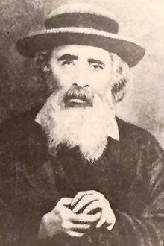

**Reb Yehoshua Leib Diskin**

THIS STORY, WHICH OCCURED in Yerushalayim of the 19th century, shows what it means to listen to the Gedolim. One day, Reb Yehoshua Leib Diskin zt"l was walking down a narrow street accompanied by several talmidim. They passed a newly opened store. Someone has opened a bookbinding business.

To the great surprise of his talmidim, Reb Yehoshua Leib went inside to meet the owner, who turned out to be a young man. The young bookbinder was overwhelmed by the surprise visit of the great Tzaddik (righteous Jew). All he could say was, "Rebbe, this Is how I hope to make a living. Please bentch (blessing) me. I just started this bookbindery…"

The Tzaddik answered, "If you are careful never to bind books that are written by apikorsim (heretics), Hashem Himself will bentch you!"

From then on, the young bookbinder was determined to avoid all books from questionable authors. He was worried, however, for he was a simple lad. How could he recognize which books were unfit and had to be avoided? He decided that every book that was brought to him, he would take to a Rav.

The Rav would check whether he could bind it, or simply give it back to the person who brought it! In those days, making a living was very difficult. Generally, only the wealthy were able to rebind books. Many of the wealthy had been influenced by the maskilim, so many of the books that the young bookbinder brought to the Rav were unfit. Yet, how could he make a living from books what were written by apikorsim?

Most of the little money he earned, the young bookbinder gave to his sick parents who were unable to work, while he himself ate little more than dry bread. Still, he was happy that he was able to do as Reb Yehoshua Leib had instructed him.

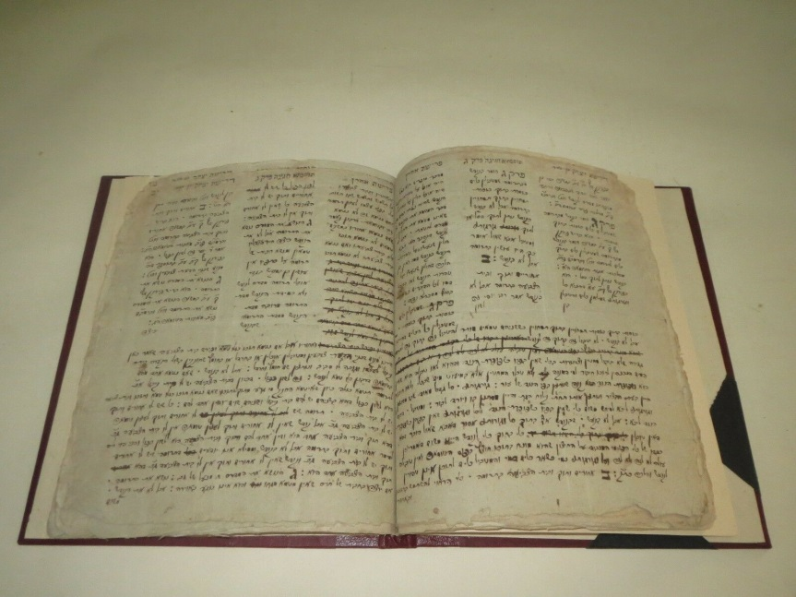

**19th Century Jewish manuscript**

One day, a book dealer driving a wagon full of books pulled up in front of the humble bindery. He came inside and offered the young man a large sum of money to bind all of the books on the wagon.

Suspicious, the young book binder said, "Please excuse me," and stepped outside, looking to see if there was a Rav passing by. Finally, he saw a Rav and asked him to check a few of the dealer's books. His suspicions turned out to be correct. The Rav told him that the authors of the books were apikorsim.

Hearing this, the young man told the dealer that he would not bind any of the books. Despite the financial loss, he told the dealer, "Please take those books away from here!"

The Rav who had checked the books was greatly impressed by the lad's strength of character. He had a cousin, a wonderful girl, whose parents were looking for a suitable husband for her. He immediately decided to recommend the young bookbinder.

**In the end, the struggling bookbinder married this wonderful girl and** became a member of her very respected family! In this way, the promise made by Reb Yehoshua Leib Diskin came true. "If you will be careful never to deal with books written by apikorsim, Hashem Himself will bentch you!" If we listen to the Tzaddikim, the Gedolei Yisroel, they will lead us where we need to go, and make sure that we do not stumble. Hashem will send His brachos in all that we do.

*Reprinted from the Parshas Devorim 5780 email of the Eitz Hachayim parshasheet.*

**Rav Moshe’s Refusal to Compromise the Halacha (Law)**

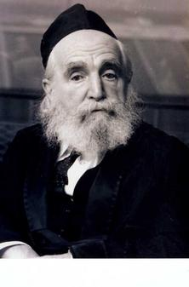

AT THE TIME THAT HARAV MOSHE FEINSTEIN ל"זצוק was Rov in [Communitst] Russia, there was a Yid, who was an informer (moser) , and he was constantly malshin on the Yidden of his community to the dreadful KGB. When he died, he left a letter for the קדישה חברה (burial society) ,stating how remorseful he felt about his actions, and begging them to bury him in a degrading matter as well as outside of the regular הקברות בית ...in order that he should have a bit of a כפרה (atonement) in the Next world for his terrible sins.

The קדישה חברה were very impressed that this רשע (wicked man) wanted to do תשובה (repentance) , and they brought the letter to Rav Moshe. Rav Moshe told them that a person is not an owner over his body and the הלכה (Jewish law) says to bury him properly and in a manner befitting a Jewish soul.

Although the קדישה חברה were a bit stunned and tried to press Rav Moshe to at least have mercy and give this man one last chance to have his כפרה (kaporah) , Rav Moshe stood firm and told them that as the Rov of the community, he can only tell them what the הלכה says and that we must follow [Jewish law]. They did as Rav Moshe said and gave the רשע (wicked man) a regular .קבורה (burial).

A few days later, the שומר (officer) of the הקברות בית (burial society) was visited by government officials, and he was told to show them where this רשע was buried. He dutifully showed them, and watched as they opened the הקבורה מקום (burial place) and checked how he was buried.

They (the government officials) explained to the guard afterward, that they received a letter from the משלין (Jewish renegade) ,that was sent just before he died, telling them that he knows that the Jewish people hate him and are going to punish him for informing on them, and they will bury him in a most degrading manner.

He asked them to please check it out and then punish them accordingly. The officials came just to check it out, yet they found everything in order and there must have been some mistake. As soon as they left, the guard, without even knowing the entire story, went to the shul to tell everyone about the unusual experience. All those in the know were awed by the gadlus (greatness) of their Rov and realized the protection of one who never budges from the word of Hashem.

*Reprinted from the Parshas Devorim 5780 email of the Eitz Hachayim parshasheet.*

**Story #1180**

**The Twelfth Pole**

**From the desk of Yerachmiel Tilles**

Five hundred years ago there lived a king in Persia who was a descendant of King Achashverosh. He took interest in the history of his family and found out that the Jewish people had in its possession an ancient handwritten parchment called "The Scroll of Esther," which describes in detail the origin of his ancestor's royal dynasty.

The Persian king researched the details of the scroll. Among other interesting facts he learned that is written in the scroll that Haman had offered to pay King Achashverosh 10,000 silver ducats for the right to do whatever he desired with the Jews in his extensive kingdom [1]. He also discovered that in the end the money was not paid. This sparked in him a clever idea.

He summoned the rabbis and the leaders of the Jewish community and asked them: "Is everything written in your Scroll of Esther true?"

The Jews could not grasp the intention of the king, but they of course assured him that everything written in Megillat Esther is true.

**King Demands an Exorbitant Ransom from the Jews**

"If that is the case", said the king, "I command you to pay the 10,000 silver ducats you owe my ancestors!"

The Jewish rabbis tried to explain to the king that King Achashverosh remitted the money to Haman, as it says explicitly in the scroll: "The money is given to you"; but the king did not give in. "I am a descendant of King Achashverosh and you are the descendants of the Jewish people. I want the money within a month. If not - you will be expelled from your homes!"

The harsh decree shocked the rabbis. All over Persia the Jewish leaders proclaimed days of prayer and fasting. The synagogues were full of people saying Psalms day and night, and large sums of charity were distributed.

The Jewish leaders tried to estimate how much money they would be able to collect. Within a few days they reached the conclusion that even if they were to sell all their properties, they would not reach the sum that the king requested. Nor would there be enough time to send emissaries to other countries in order to collect money from Jewish communities outside of Persia.

In their desperation, they decided that their best option was to send a messenger to the "**Holy Ari**," **Rabbi Yitzchak Luria**, who resided in Tsfat in the Holy Land in order to ask for his blessing and advice.

The messenger sped away on a fast camel and shortly arrived in Tsfat. He handed over the letter written by the rabbis of the Jewish community in Persia and pleaded in tears for help, asking the holy Ari to pray on their behalf to our Father in Heaven.

**The Holy Ari Went into His Private Study**

The Holy Ari went into his private study for a while and then returned to the messenger, holding a small box in his hand.

The Ari said to him: "The Jews of Persia have repented with a full heart and the evil decree has been revoked. There is no need to pay the ransom money.

"Instead, on the day of payment, the leaders of the Jewish community are to hand over this box to the king. The box must not be opened by anyone but the king."

Meanwhile, the king was very satisfied with his plan. If the Jews would pay him the money - all the better. If they did not, he would confiscate their property after the expulsion and would make a tidy profit in any case.

That night the king did not sleep well. He had a fearful dream:

**A Mighty Storm Raged Outside the Palace**

A mighty storm was raging outside his palace. Suddenly the windows to his room burst open. A man clad in white with fiery eyes entered his room through the window. The king wanted to cry for help, but the words got stuck in his throat and he was unable to utter a word.

The white figure took him by the hand and led him outside through the open window. They passed houses and fields until they reached a forest. There was an open area between the trees.

The white figure turned to the king and asked him in a stern voice: "What do you see in the open area?"

"I see a high pole - and somebody is hanging from its top," the king said in fear.

They continued their walk another few steps, and again the figure in white asked the king what he saw.

"I see another high pole with somebody hanging from its top - and there is another one and yet another..."

"How many poles do you see?" the figure asked.

"I can see eleven poles with people hanging from the top - and over there is another pole - but nobody is hanging from it," said the king, trembling with fear.

"The people hanging there are Haman and his ten sons [2]," said the figure to the king. "The empty pole is meant for people who walk in their evil ways!"

**The King was Shocked by the Threat**

A shiver went over the body of the king.

The white figure took the king by his hand and led him back to the king's palace. The figure made the king sit down next to his desk and said, "Write that you relinquish all your claims against the Jews and sign the document with the royal seal!"

The king wrote the document with a trembling hand, signed it, and stamped the royal seal over his signature. He handed the document to the man in white who disappeared through the window.

Suddenly the king woke up from his nightmare. He found himself sitting next to his desk, shivering with fear and his face covered by cold sweat.

Outside there was a quiet summer night.

"What a strange dream I had," he thought and went back to sleep in his bed.

The following morning he still remembered the dream but dismissed it.

The messenger came back from Tsfat to the Jewish leaders in Persia with good tidings. Still, the Jews did not rest the whole month. The studied much Torah, spent many hours in prayer every day, and took upon themselves to correct everything that needed to be corrected. Especially, they asked forgiveness of each other and acted with brotherly love.

**The Designated Day Finally Arrived**

When the designated day came, the leaders of the Jewish community took the box that they had received from the Holy Ari and approached the king.

"Where is my money?" the king roared.

"Your majesty, we have brought this box for you," said the spokesman of the delegation and handed the box to the king.

The king took the box in his hand, opened it and found a signed document inside. When he started to read what was written there, he suddenly screamed in terrible fear and fell in a swoon to the floor.

The king's doctors who immediately were summoned finally managed to wake him up. The king was trembling hands and feet.

"So it was not a dream," he whispered in panic. "The next hanging pole was meant for me because of my behavior towards the Jews..."

Nobody knew what he was talking about, but when he recovered somewhat he gave over the document to the Jewish leaders and said: "Everything which is written in this document is hereby established in law. I give up all my claims regarding the debt. I promise not to harm any Jew from now on. You are released from all previous monetary claims as well."

**Great Joy for Jews all Over the Persia**

The Jewish leaders immediately dispatched a special messenger in order to express their gratitude to the Holy Ari. All over Persia the Jews celebrated parties of thanksgiving to G-d for their wonderful delivery. "The Jews had light and happiness and joy and honor."

**Source:** Adapted by Yerachmiel Tilles from "Chassidic Gems," by Tuvia Litzman.

**Connection:** Saturday night will be the 448th yahrzeit of Rabbi Yitzchak Luria, the "Holy Ari," leader of the 16th century Safed Kabbalists.

**Biographic note:** **Rabbi Yitzchak Luria** [of blessed memory: 5294 - 5 Av 5332 (1534 - July 1572)], Known as "the holy **Ari**," revolutionized the study of Kabbalah and its integration into mainstream Judaism during the two years he spent in Zefat before his death at 38.

*Reprinted from the Parshat Devarim 5780 email of Kabbalahonline.org, a project of Ascent of Safed.*

**Exploring Asia in Brooklyn**

**By Freddy Ezekiel**

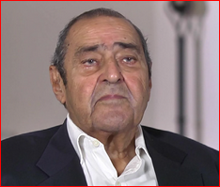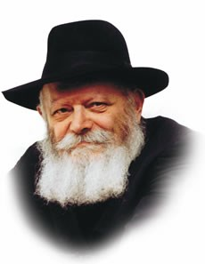

**Freddy Ezekiel Lubavitcher Rebbe, zt”l**

I was born in Shanghai, China, where my grandfather – Judah Abraham – served as one of the leaders of the Sephardic community. In 1948, when I was twenty-one, I moved to Hong Kong where I stayed until 1963 or so, and then I immigrated to London. That is where I got married and lived until moving to Miami nearly forty years ago.

Back in 1962, while still living in the Far East, I attended a Bar Mitzvah of a relative in New York, where I met a number of young chasidic rabbis, one of whom – I later surmised – must have reported to his Rebbe that a Jew from Hong Kong was in town.

**A Message that the Lubavitcher Rebbe Wanted to Meed Freddy**

At that time, I was staying in Brooklyn with my friend Benny Fishoff, who had lived in Shanghai during the war years, and a message came to his house that the Lubavitcher Rebbe would like to meet with me. I had no idea who this was – and I remember putting my hands over the telephone speaker and whispering to Benny, “Who is the Lubavitcher Rebbe?”

It was a surprising meeting. I recall that, when I walked into the Rebbe’s office, what immediately struck me was the simplicity of the room, which was dominated by a desk with a gentleman sitting behind it. As I entered, he rose to greet me and shook my hand.

He asked me questions about myself and he also spoke of his own background, and from that point, we began discussing our shared Jewish heritage and how that is observed by the different communities throughout the world.

While we were talking – he spoke an excellent English, by the way – I looked at my watch several times, not wanting to overstay my welcome. After hours passed – when it was eleven, and then when it was eleven-thirty, and then twelve – I got worried. But the Rebbe said, “Don’t worry about the time – we still have much to talk about.”

**Answering the Rebbe’s Many Questions**

**About Jewish History in the Far East**

During most of our conversation, I was answering his questions, relating the history of the various Jewish communities in the Far East – in India, Singapore, China, etc. He was very interested in the history of the Sephardim who came from Baghdad and established various communities in Asia. And also, he wanted to know the history of the Ashkenazim who fled there from the Nazis.

He wanted to know all the details. He asked me many questions about how the various communities got along, about their traditions, about the existing infrastructures – the synagogues, the schools, the mikvehs etc.

I recall telling him how Shanghai changed with the outbreak of the Pacific War in 1941. Up until then, Shanghai was in Japanese hands, and it was a thriving city, with a prosperous Jewish community which looked after the thousands of refugees who fled from Nazi-occupied Europe. But the Pacific War disturbed everything. When it ended, and the Chinese Communists came into Shanghai, all the Jews left so that, by the time I was speaking with the Rebbe, the Jewish community there was nearly extinct.

And yet he still asked so many questions about Shanghai. He also asked about Tokyo and Kobe and Manilla. I recall thinking: Why is he so interested in the fifty families living in Hong Kong? Why is he so interested in the few Jews left over in Japan? Why do the ones in the Philippines matter so much to him?

Obviously, he had a far-reaching vision of how things would change in the coming decades, and he was thinking ahead. I have to say that it never occurred to me to wonder what the future would hold for Yiddishkeit in the Far East. The thought didn’t cross my mind. Whereas, clearly, it had been on the Rebbe’s mind. He was already anticipating how the world would change, and he must have been thinking not just how to preserve some of the dwindling Jewish communities in Asia but how to develop them.

Today, there are thousands of Jews in Shanghai. And Chabad is there – with three Chabad centers – to give them all the strength they need. In Hong Kong there are now five strong communities with five synagogues and two Chabad centers. Whereas in 1962, it was hard to get a minyan together. In total, Chabad has thirteen centers in China!

The Rebbe saw into the future and the starring role that Chabad would come to play in these communities. Indeed, he gave me a clue of how he envisioned that happening, but at the time I didn’t fully grasp his intention.

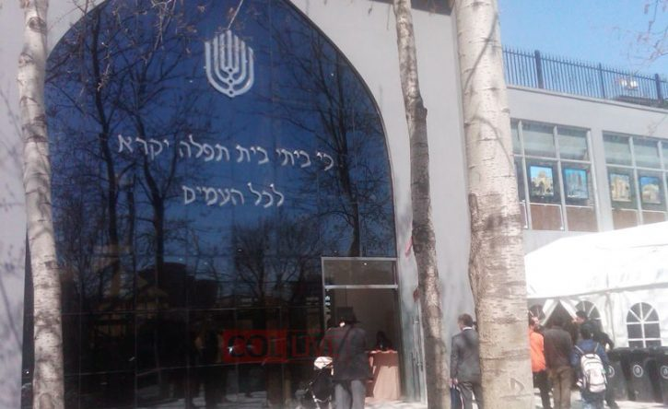

**Chabad Lubavitch of Beijing, China**

I remember that he told an anecdote about a lake, the water of which was completely smooth, except when someone would throw in a pebble. Then the still waters would ripple out in concentric circles, spreading through the entire lake. When he related this anecdote, he said, “This is what Jewish influence is like. No matter how small a pebble you drop into the water, the ripples reach the furthest edges.”

Later, as I learned more about the Rebbe and Chabad, I asked myself the question: How did the Rebbe come to have so much influence over so many people? And this anecdote provided the answer. It all came down to the ripples he created and how they spread throughout the world.

For thirty years (from 1980 to 2010), Mr. Freddy Ezekiel was a supplier of electronics to South America. He was interviewed in his Miami home in April of 2018.

Reprinted from the Parshat Devarim 5780 edition of Here’s My Story